**REACT**

**Hands On - 4**

Create a React Application named “ticketbookingapp” where the guest user can browse the page where the flight details are displayed whereas the logged in user only can book tickets.

The Login and Logout buttons should accordingly display different pages. Once the user is logged in the User page should be displayed. When the user clicks on Logout, the Guest page should be displayed.

**App.js**  
import React, { useState } from "react";

function LoginButton({ onClick }) {

  return <button onClick={onClick}>Login</button>;

}

function LogoutButton({ onClick }) {

  return <button onClick={onClick}>Logout</button>;

}

function UserPage() {

  return (

    <div style={{ textAlign: "center" }}>

      <h1>Welcome Back</h1>

    <div style={{ textAlign: "center" }}>

      <h1>Available Flights</h1>

      <ul style={{ listStyle: "none", padding: 0 }}>

        <li>

          Chennai ➝ Delhi – 10:00 AM{" "}

          <button style={{ marginLeft: "10px" }}>Book Ticket</button>

        </li>

        <br />

        <li>

          Chennai ➝ Singapore – 8:00 PM{" "}

          <button style={{ marginLeft: "10px" }}>Book Ticket</button>

        </li>

        <br/>

        <li>

          Chennai ➝ TaekookWorld – 8:00 PM{" "}

          <button style={{ marginLeft: "10px" }}>Book Ticket</button>

        </li>

      </ul>

       </div>

    </div>

  );

}

function LoginPage(){

  return(

    <div style={{textAlign:"center"}}>

      <h1>Please Login</h1>

    </div>

  )

}

function App() {

  const [isLoggedIn, setIsLoggedIn] = useState(false);

  const handleLoginClick = () => setIsLoggedIn(true);

  const handleLogoutClick = () => setIsLoggedIn(false);

  return (

    <div  style={{

        padding: "20px",

        textAlign: "center",

        fontFamily: "Arial, sans-serif",

      }}    >

      {isLoggedIn ? <UserPage /> : <LoginPage />}

      <div style={{ marginTop: "20px" }}>

        {isLoggedIn ? (

          <LogoutButton onClick={handleLogoutClick} />

        ) : (

          <LoginButton onClick={handleLoginClick} />

        )}

      </div>

    </div>

  );

}

export default App;

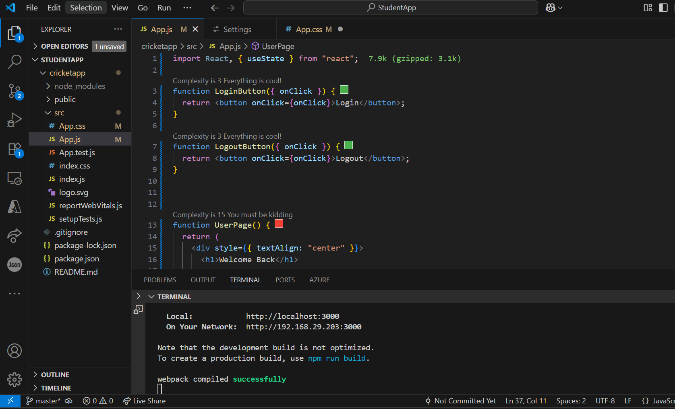

**Output:**

